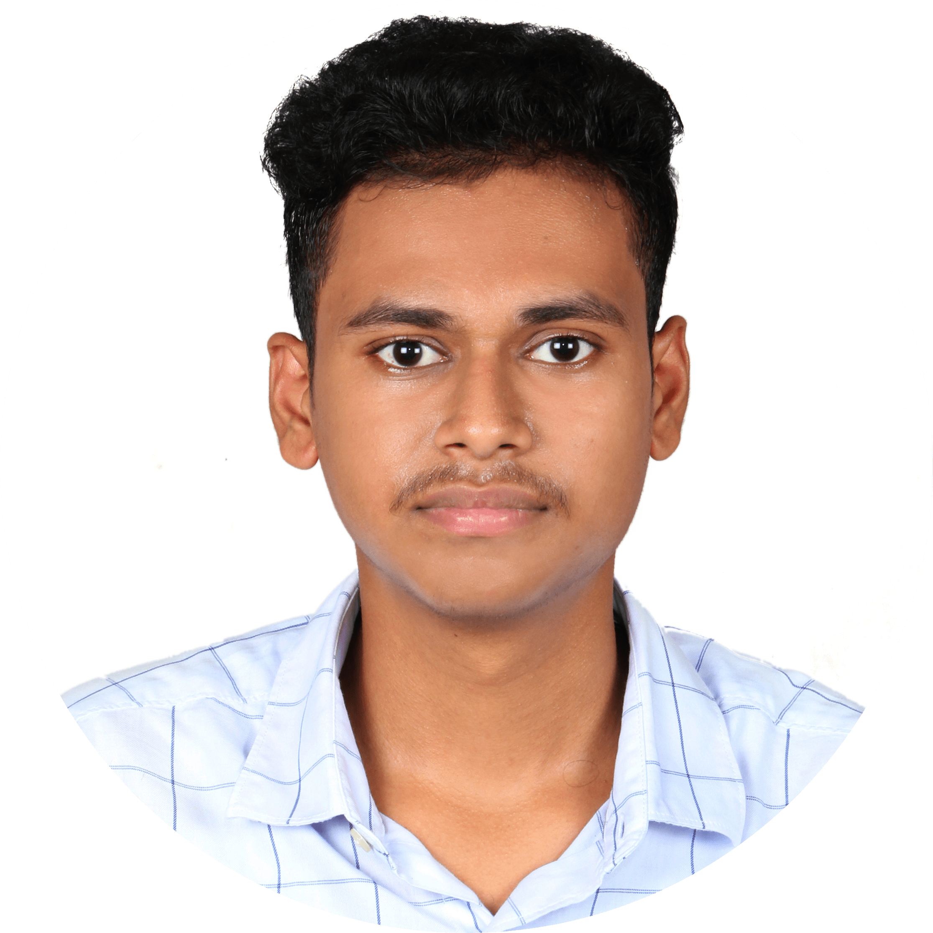

Skills

* C – Language, C++
* Python, Django
* HTML, CSS, SASS, JavaScript
* Data Structures and Algorithms

Interests

* Creating responsive websites
* Learning new software
* Learning Languages
* Music

Languages

* English
* Telugu

Summary

Enthusiastic engineering graduate with basic knowledge in coding and design. Proficient in C, C++, HTML,CSS , JavaScript, and Python. Ability to learn new softwares and technologies quickly. Capability to work in teams by providing valuable support.

Education

## Sathyabama Institute of Science and Technology, Chennai — ***B.E.***

### 2019 - 2023

* **Electronics and Communication Engineering**
* Aggregate: 8.7 CGPA

## Tirumala Junior Kalasala, Rajahmundry — ***Intermediate***

### 2017 - 2019

* **Mathematics, Physics, Chemistry**
* Aggregate: 10 CGPA

Bhashyam E.M. High School, Kakinada — ***SSC***

2016 - 2017

* Aggregate: 10 CGPA

Personal Projects

* IOT based Home Automation and Security System using Blynk App
* Bluetooth controlled RC car using Arduino

Certifications

* IOT based Home Automation and Security System using Blynk App  **(August 2021 – September 2021)** ***NSIC, Hyderabad***
* C – Language **(April 2019 – May 2019)**

***IIET***

* Python for Beginners

***Udemy***

[**linkedin.com/in/ram-nivas-anusuri-044130216**](http://www.linkedin.com/in/ram-nivas-anusuri-044130216)

**+91-9494921767**

[**github.com/ramnivasanusuri**](https://github.com/ramnivasanusuri)

[**ramnivas2001@gmail.com**](mailto:ramnivas2001@gmail.com)

**Ram Nivas Anusuri**

 

** **